Want to tell us about our service?
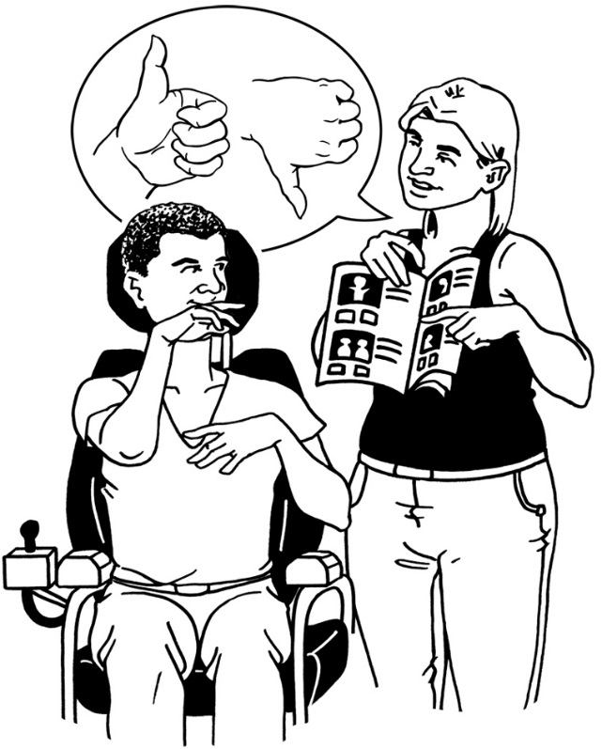
This information tells you how you can give us feedback or make a complaint

Easy Read
2015
CCS Disability Action want to hear what you have to say about our services.

Hearing about what we are doing well helps us keep doing good work.

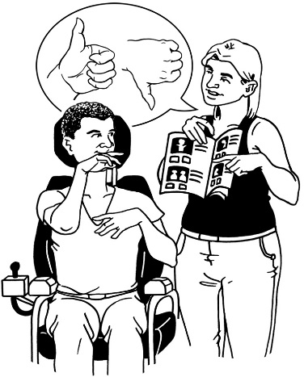
Hearing about what we are not doing well helps us make changes to services to make them better for you.

There are different ways you can tell us what you think about our services:

- talking to a staff person

- emailing or writing to the General Manager.

Anyone can contact us to tell us:
- what they think is working well

- what is worrying them about the service

- what they are not happy about.

This book will tell you about:
- how to make a complaint if you are not happy about a service at CCS Disability Action

- your rights.

How to make a complaint to
CCS Disability Action

CCS Disability Action supports people to speak up when they are not happy.

We will help you speak up in a way that you choose.

You can have people support you when you make a complaint.

People that could help you are:
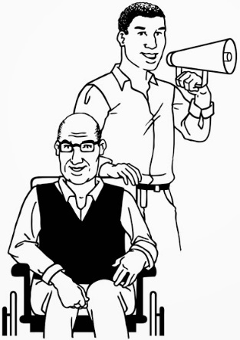
- support people

- advocates

- interpreters

- your family

- your friends.

You can talk or write to your CCS Disability Action Service Leader or General Manager.

You can write to your CCS Disability Action Service Leader or General Manager.

If you are still not happy after your complaint has been dealt with you can talk or write to:

- Health and Disability Commissioner

- Human Rights Commission.

The contact details for these
places are on Page 14

What does CCS Disability Action do when you make a complaint?
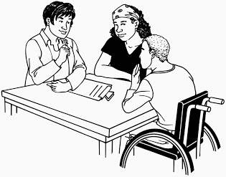
CCS Disability Action will:

- write down your complaint
- get back to you within 5 days of you making the complaint.

When we look at your complaint we follow:
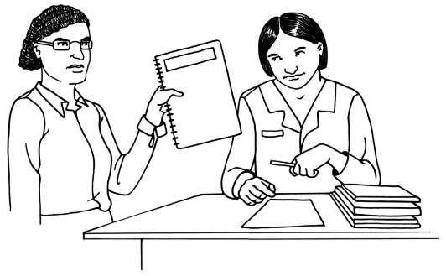
- the Code of Health and Disability Services Consumers’ Rights

- CCS Disability Action’s Human Resources guidelines.
After 10 days CCS Disability Action will tell you:

- what is going to happen because of your complaint

- if we need more time to sort out the complaint.

If we need more than 10 working days to sort out your complaint we will tell you.

When we make a decision about your complaint we will:

- tell you why we made the decision
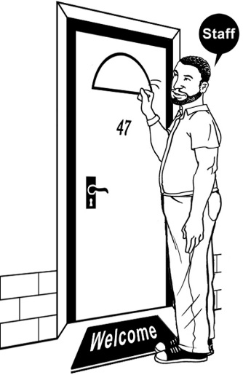
- what changes we are going to make because of your complaint

- what you can do if you are not happy with the decision we have made.

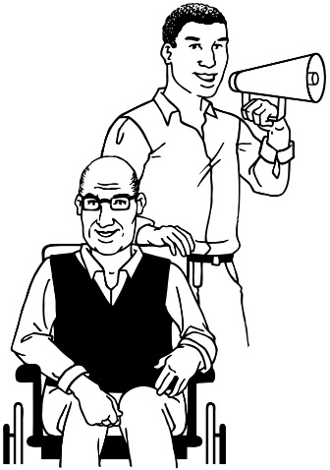

We take your rights seriously.

We will always try to:
- be fair

- keep things easy

- work quickly.
Your rights

You have the right to:

- have your complaint and what happened from it kept in CCS Disability Action’s files

- get all the information about the complaint in a way that you can understand and that suits you

- to have a support person at all times
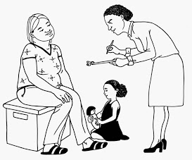

- to contact the Health and Disability Commissioner about your complaint

- to have an independent advocate through the Health and Disability Commissioner Act 1994

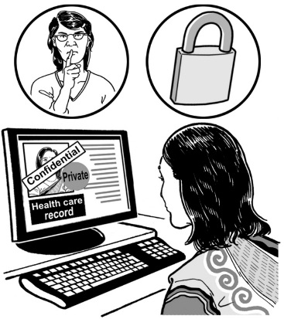
- to be treated with respect

- for your complaint to be kept private

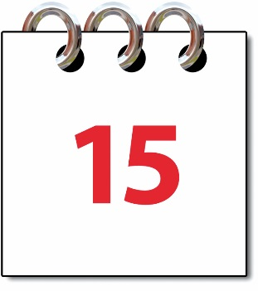
- to be told what is happening with your complaint every 15 working days.

How to contact CCS Disability Action

You can contact us here:

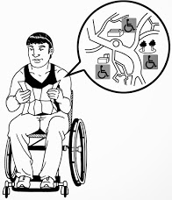
National Office:
Level 3 Orbit Systems House,
94 Dixon St, Wellington 6011
Post to:
PO Box 6349,
Wellington 6141

Phone:
04 801 0854
Or 0800 227 2255 (free to call)

Fax:
04 382 9353
Email: info@ccsDisabilityAction.org.nz

Other places you can get support to make a complaint
Health and Disability Advocacy Service
Phone: 0800 555 050 (free to call)

Health and Disability Commissioner
Phone: 0800 11 22 33 (free to call)
Website: www.hdc.org.nz
Post:
PO Box 1791
Auckland 1140

Human Rights Commissioner
Phone: 0800 496 877 (free to call)

Privacy Commissioner
Phone: 0800 803 909 (free to call)

This information has been translated into Easy Read
by People First New Zealand Inc.- Nga Tangata Tuatahi

